SIMATS ENGINEERING (SAVEETHA SCHOOL OF ENGINEERING)
Department of Computer Science and Engineering
ASSESSMENT TOOL 1 – Coding Challenge Task
Course Code: | CSA06 | Course Title: | Design and Analysis of Algorithms
CO Assessed: | CO4: Articulation (BL4, BL5) | Assessment: | Assessment Tool 1 – Coding Challenge Task
Weightage: | 40% of CIA | Total Marks: | 100 (2 Questions × 50 Marks)
CO4 Statement: | Solve optimization problems using dynamic programming and greedy strategies.
Student Name: | S Suvikumar | Reg. No.: | 192424262
Section / Batch: | AI&DS | Date:

Instructions to Students
- Answer both questions. Each question carries 50 Marks. Total: 100 Marks.
- Carefully analyze the given questions.
- Write clear code for the given problem.
- Analyze the Time complexity and Space complexity of your code using dynamic programming and greedy strategies

Question Type | Description | Questions | Total Marks
Coding Challenge Task | Focus on Code and analyze optimization problems using dynamic programming and greedy strategies | Q1 – Q2 | 100

SECTION A – Coding Challenge Task

Q58.Maximum Number of Non-Overlapping Segments
Given a set of segments, select the maximum number of non-overlapping segments. The goal is to maximize the count of segments selected. Use Greedy strategy to solve efficiently.
Input Format:
n = number of segments
start[], end[]
Sample Input:
n = 3
(1,2) (2,3) (3,4)
Expected Output:
Max Segments = 3

Q59.Minimum Cost to Connect Ropes
Given ropes of different lengths, connect them into one rope with minimum cost. The cost of connecting two ropes is equal to their sum. The objective is to minimize total cost. Use Greedy strategy.
Input Format:
n = number of ropes
arr[] = lengths
Sample Input:
n = 4
arr = 4 3 2 6
Expected Output:Min Cost = 29

Code of Conduct
I __________________________ (Name / Reg No) certify that this submission is my original work and that I have adhered to the guidelines specified for this assessment. I understand that any violation of academic integrity rules will result in disciplinary action.
Signature of the Student: _________________________

RUBRICS FOR CALCULATION
Coding Challenge Task

Criteria | Weightage | Level 4 (Exemplary) | Level 3 (Proficient) | Level 2 (Developing) | Level 1 (Beginning)
Problem Understanding | 20% | Clearly understands problem constraints, edge cases, and competitive requirements | Understands problem with minor gaps in constraints | Partial understanding; misses key constraints | Misinterprets problem or constraints
Algorithm | 25% | Selects optimal algorithm with best time and space complexity for competitive constraints | Uses efficient algorithm with minor scope for improvement | Uses basic/inefficient approach | No clear algorithmic approach
Code Implementation | 20% | Writes correct, efficient, and clean code that passes all constraints | Code works with minor errors or inefficiencies | Partially correct code; fails for some cases | Code does not execute or gives incorrect results
Competitive Performance | 20% | Solves problem within time limits and handles large inputs effectively | Solves within acceptable time with minor delays | Struggles with time limits or larger inputs | Unable to solve within time constraints
Test Case Handling | 15% | Handles all test cases including edge and hidden cases | Handles most test cases | Misses important edge cases | Fails on multiple test cases

Mark Evaluation:
Questions | Problem Understanding (20) | Algorithm (25) | Code Implementation  (20) | Competitive Performance  (20) | Test Case Handling  (15) | Total Marks  (Each - 50)
Q1
Q2
Overall Total

Faculty In-charge | Course Coordinator | Head of Department
Name: __________________  Signature: _______________ | Signature: _______________ | Signature: _______________
Date: ___________________ | Date: ___________________ | Date: ___________________

58. Aim
To find the maximum number of non-overlapping segments from a given set of segments using the Greedy Algorithm.

Algorithm
- Read the number of segments n.
- Store all segments as (start, end) pairs.
- Sort the segments based on their ending times.
- Select the first segment.
- Traverse the remaining segments:
  - If the start time of the current segment is greater than or equal to the end time of the last selected segment, select it.
- Count the selected segments.
- Display the maximum number of non-overlapping segments.
Python Code
n = int(input("Enter number of segments: "))
segments = []
print("Enter start and end times:")
for i in range(n):
start, end = map(int, input().split())
segments.append((start, end))
# Sort by ending time
segments.sort(key=lambda x: x[1])
count = 1
last_end = segments[0][1]
for start, end in segments[1:]:
if start >= last_end:
count += 1
last_end = end
print("Max Segments =", count)

Output
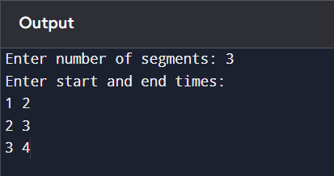

Result
The segments selected are (1,2), (2,3), and (3,4). Since none of them overlap, the maximum number of non-overlapping segments is 3. The Greedy strategy correctly finds the o

59. Aim
To find the minimum cost required to connect all ropes into a single rope using the Greedy Strategy (Min Heap).

Algorithm
- Read the number of ropes n.
- Read the lengths of the ropes into an array.
- Insert all rope lengths into a min-heap.
- Initialize cost = 0.
- While more than one rope remains:
  - Remove the two smallest ropes from the heap.
  - Connect them and calculate their sum.
  - Add this sum to cost.
  - Insert the new rope back into the heap.
- Repeat until only one rope remains.
- Display the minimum total cost.

Python Code
import heapq
n = int(input("Enter number of ropes: "))
arr = list(map(int, input("Enter rope lengths: ").split()))
heapq.heapify(arr)
cost = 0
while len(arr) > 1:
first = heapq.heappop(arr)
second = heapq.heappop(arr)
new_rope = first + second
cost += new_rope
heapq.heappush(arr, new_rope)
print("Min Cost =", cost)

Output
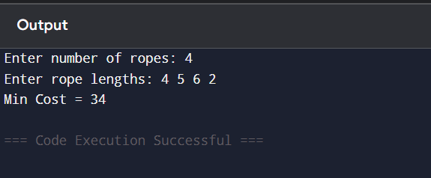
Result
Thus, the Greedy Algorithm using a Min Heap was successfully implemented to find the minimum cost of connecting ropes. For the given rope lengths 4, 5, 6, 3, the minimum cost is 34.

